Statistics HW13 b03705002林軒逸

11.35

Step 1. Let the mean life time of long-life bulb be u.

The alternative hypothesis(H1): u>5000

The null hypothesis(H0): u≤5000

It is a one-tail test. (right-tailed)

Step 2. Since the sample size is bigger than 30, so we can say the mean of it is normally distributed. Test statistic x̅ is normally distributed, and we can use central limit theorem.

Step 3. α =0.05, the level of significance is 5%.

Step 4. We will use the method of p-value rule to find evidences to reject H0.

Step 5. By excel, we know the information.

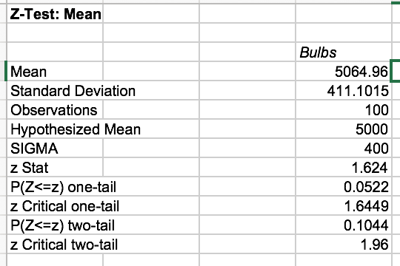

Step 6.

p-value is 0.0522>0.05, so we don’t have enough evidences to reject our null hypothesis. That is, we have no enough evidences to conclude at 5% significance level that the long-life bulb can last more than 5000 hours(H1) is true. (no enough evidences to prove that the null hypothesis u≤5000 is false)

11.39

Step 1. Let the mean of person-hours lost be u

H1(alternative hypothesis): u<0

H0(null hypothesis): u≥0

It is a one-tail test. (left-tailed)

Step 2. Since the sample size is bigger than 30, so we can say the mean of it is normally distributed. Test statistic x̅ is normally distributed, and we can use central limit theorem.

Step 3. α =0.10. The level of significance is 10%.

Step 4. We will use the method of p-value rule to find evidences to reject H0.

Step 5. By excel, we know the information:

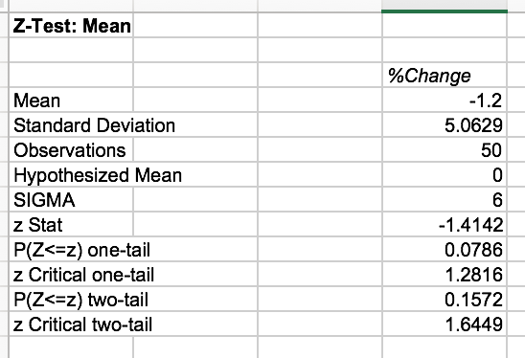

Step 6. p-value is 0.0786< 0.1, that is, we have enough evidences to reject the null hypothesis. That is, the alternative hypothesis is correct, and the new safety equipment is effective.

11.45

Step 1. Let the men of reduction of strokes be u.

H1(alternative hypothesis): u>5

H0(null hypothesis): u≤5

It is a one-tail test (right tailed).

Step 2: Since the data is normally distributed, then the test statistic x̅ is also normally distributed, and we can use central limit theorem.

Step 3: α =0.10, the level of significance is 10%.

Step 4. We will use the method of p-value rule to find evidences to reject H0.

Step 5. By excel, we know the information:

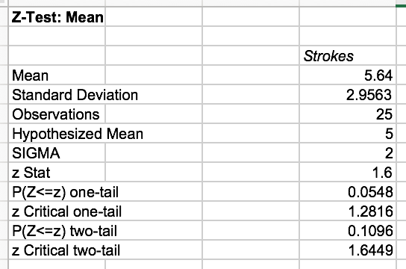

Step 6.

Since the p-value 0.0548<0.1, we have enough evidences to reject our null hypothesis. That is, out alternative hypothesis is correct, and the golf professional’s claim using a 10% significance level is correct.

11.55

It is a left tail test.

a.

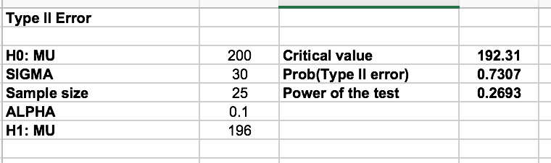

The probability of type II error is 73.07%.

b.

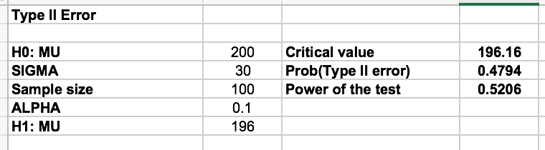

The probability of type II error is 47.94%.

c.

When the sample size gets bigger, the probability of type II error decreases.

11.61

The probability of failing to reject a false null hypothesis is a type II error. That is, by excel, we can know the information: (left tail test)

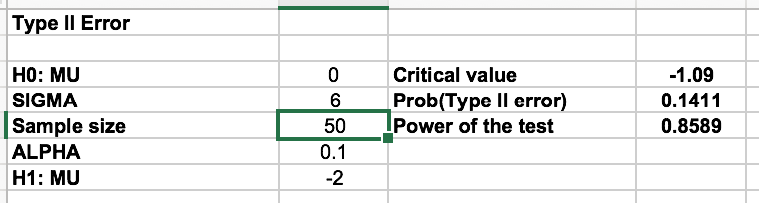

The probability of a type II error, that is, losing a chance to install very effective equipment is 14.11%. To decrease the probability of type II error, we can increase the sample size or increase the significance level (α). (left tail test)

11.67

It is a right tail test.

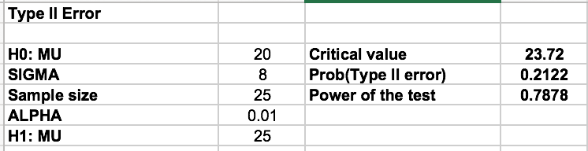

When the real wind velocity is 25mph, we should reject the null hypothesis of u≤20, and the probability of not conclude that the site is feasible, (failing to reject H0 when H0 is false) is β, and the probability is 21.22%. (right tail test)